

**Become an Early National PLACE Member**

***''Ensuring a PLACE at the table for Every Family"***

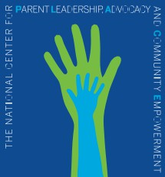**Come join** us at this very important national table, where members will gather to work on and collectively promote enhanced meaningful parent involvement and leadership in ALL policy decision-making that impacts services for our nation’s children and families across systems.

7.

*w*

Because we are building this organization from the ground floor, we are featuring special rates for anyone joining us in this first year! Member benefits include:

* Opportunity to be integral part of a formidable group focused on impacting

family engagement and leadership policies in education, health & mental health, early childhood, human services, child welfare, etc.

* National PLACE website-"Members Only” section; On-line training opportunities; national map of members; easy-to-use steps to act on legislation
* Timely access to critical policies and legislative news

**Yes! Reserve My PLACE at the TABLE!**

**Introductory Membership Options**

**D** State /Local Parent Organization or Committed Individuals. $250

**D** National Organizations. $500

**Additional Support**

**D** I want to be a catalyst for change! Please accept my donation for this important work! National PLACE is a 501©3 and donations are tax deductible. EIN 46-3412035 $

Organization Name _ Individual Name



Email Phone: ( )

Organization website, if appropriate _

# of families I /we impact/serve annually

For more information about National PLACE, check out our website at [www.parentsatthetable.org](http://www.parentsatthetable.org/)