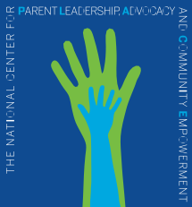


Ensuring a Place at the Table for Every Family

Dear Mr. Choe:

The National Center for Parent Leadership, Advocacy, and Community Empowerment (National PLACE) is a national non-profit composed of 70 local, state, and national family-led organizations around the country. Our vision is that all families will be effective partners in improving services to and outcomes for our nation’s children, especially those who face the greatest challenges. Our mission is to empower families and family-led organizations to advocate for enhanced, meaningful parent involvement and leadership in all policy decision-making that impacts services for children and families across child welfare, education, health, and other systems. Our members include organizations that support families involved in the child welfare system.

We are writing to strongly encourage you to keep Jerry Milner as the leader of the Children’s Bureau. He is visionary, dedicated, and progressive. He has been forward-thinking during this challenging time of COVID-19, encouraging states to recognize and address the additional challenges that COVID-19 has brought to children and families involved in the child welfare system. He has also been a champion for racial equity and justice in a system that is extraordinarily racially and socio-economically unjust. He and his Special Assistant, David Kelly, have been a breath of fresh air at the Children’s Bureau.

Milner recognizes the importance of garnering information and insights from people with lived experience in the system, including providers but most importantly also including families whose children are under the jurisdiction of child welfare, both those whose children still live with them at home and those who have been displaced into foster care. He is also deeply interested in hearing from those family-led organizations who support and advocate for children and families, including our members. He is honest and forthright about the problems in the system and shows great compassion for the families who are ill-served by it.

Despite the fact that he became head of the Children’s Bureau under a regressive, anti-family administration, he is someone who shares the values of the Biden Administration and is dedicated to ensuring those values are embedded in the child welfare system. It would be a tremendous loss to children and families, and a disappointing message to those of us advocating to improve child welfare, should he be removed from this important office just at the time that his presence could do so much good.

Very truly yours,

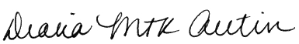

Diana Autin, Executive Director
National Center for Parent Leadership, Advocacy, and Community Empowerment
National PLACE
dautin@parentsatthetable.org
www.parentsatthetable.org

