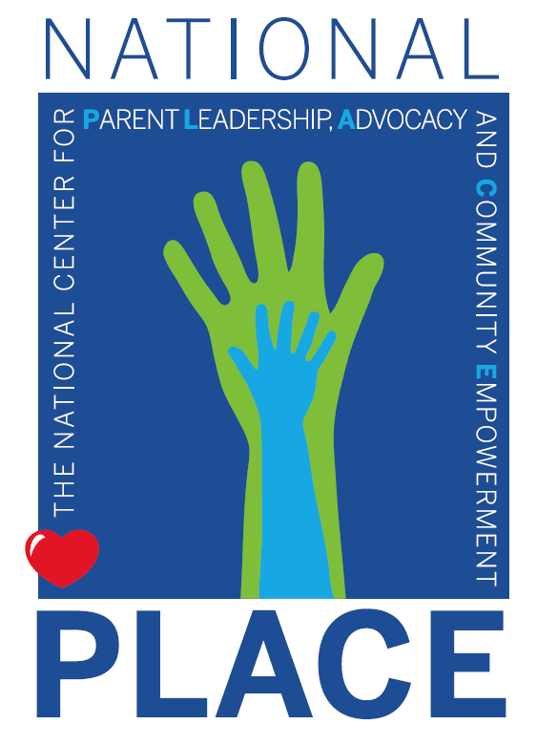

Families in Jeopardy: Threats to Children and Families in the Proposed Federal Budget

NATIONAL PLACE Mission and Vision

Mission: To educate and empower families and family-led organizations and support them to advocate for enhanced parent involvement and leadership in education, health and human services decision-making with regard to services for children and families.
Motto: Advocating to ensure the parents’ PLACE at decision-making tables

Public Policy Advocacy for Social Change

“Never doubt that a small group of thoughtful, committed [people] can change the world. Indeed, it is the only thing that ever has.”
-Margaret Mead

The National Context

EDUCATION

$100 Answer: US Secretary of Education Betsy DeVos
$100 Question: Who said: “We had to make some difficult decisions with this budget” when supporting a 26% cut to special education grants to states & cuts affecting programs for the deaf & blind without consulting the families whose children are the intended beneficiaries?

$200 Answer: Elimination of funding for:
- Statewide Family Engagement Centers,
- 21st Century Community Learning Centers,
- comprehensive literacy development grants, and
- Regional Educational Labs
$200 Question: What proposals in the President’s budget will reduce support for parent-school engagement?

$300 Answer: All of them!
- FREE Appropriate Public Education in LRE
- Discipline protections
- Parents’ rights to be part of decision-making
- Due process procedures
- Progress reports
You name it, you lose it!
$300 Question: What rights would students with disabilities lose in the voucher-like “scholarships” to private schools proposed in the President’s budget? (The proposal would allow $5 billion in federal tax credits for donations to organizations that provide voucher-like scholarships to private schools.)

$400 Answer: Betsy DeVos. “This reduction is similar to last year’s request, and the year before that, as well. I acknowledge that you rejected those recommendations. I also acknowledge that it’s easier to keep spending, to keep saying ‘yes,’ and to keep saddling tomorrow’s generations with today’s growing debt. But, as it’s been said, the government will ‘run out of other people’s money.’”
$400 Question: Who testified before Congress? What did she say in support of a $7.1 billion/10% cut in funding to her own Department while supporting a $60 million increase in charter school funding?

$500 Answer:
- Making it harder for students to complain about sexual harassment under Title IX (input period over)
- Reducing requirements for State Education Agencies and districts to develop understandable report cards that contain all the information parents need to assess their schools (comments due April 29)
- Funding IDEA implementation studies without asking a single question of a parent, student, Parent Center, or other family-led organization (comments due June 14)
$500 Question: What are current key proposals of US ED for which they have recently requested or are requesting “input,” and did not consult with parents of intended beneficiaries?

HEALTH

$100 Answer:
- US Department of Justice asks the U.S. Court of Appeals for the Fifth Circuit to invalidate the entire Affordable Care Act (ACA), causing millions of people to lose health coverage and make coverage worse or less affordable for millions more, including up to 130 million with pre-existing conditions.
- The Centers for Medicare and Medicaid Services (CMS) proposes changes to a technical insurance formula that would leave the large majority of people who purchase subsidized marketplace coverage under the Affordable Care Act (at least 7.3 million marketplace consumers) paying higher premiums and lead 100,000 people to drop coverage each year, by the Administration’s own estimates. It would also raise limits on total out-of-pocket costs for millions of people, including many with employer coverage, leaving families that have costly illnesses or injuries facing an additional $400/year in medical bills and hitting people with pre-existing conditions especially hard.
$100 Question: What are the two most recent attempts by the Administration to undermine the Affordable Care Act & reduce health coverage for millions of Americans?

$200 Answer:
- States would not receive funds for every eligible child/family (no allowance for increase in population or increased need during recession); 24 million people could lose health insurance.
- States would no longer be required to provide all medically necessary services or Early Periodic Screening, Diagnosis & Treatment.
- States could charge unlimited premiums, deductibles, & co-payments.
- Medicaid would be cut $1.5 trillion over 10 years!
- Elimination of all federal Medicaid administration requirements, including state obligations to allow anyone to apply for assistance; to provide medical assistance with reasonable speed; to maintain anti-fraud oversight systems; and even obligations to maintain the efficiency and quality of care.
$200 Question: Why would Medicaid block grants be bad for children, especially with special needs?

$300 Answer:
- Nearly $1.5 trillion would be cut from Medicaid over 10 years.
- Medicaid would be turned into a block grant or per-person cap program to start in 2021.
- Funding for the 36 states that expanded Medicaid would end.
- Nationwide work requirements would be instituted, causing hundreds of thousands of eligible families and individuals to lose Medicaid coverage. When Arkansas instituted work requirements for Medicaid, 20% of Medicaid recipients lost coverage – and most because they couldn’t keep up with the reporting requirements! The work requirement in Arkansas is now locking out enrollees who are already working or who should be exempt from the work requirement.
$300 Question: What does funding for Medicaid, the health insurance lifeline for low-income families & families of & people with disabilities look like in the President’s budget proposal?

$400 Answer:
- 37 million children on Medicaid and over 9 million on SCHIP, for a total of 46 million on Medicaid/SCHIP!
  - 40% of US children are enrolled in Medicaid, >60% enrolled in Medicaid & SCHIP
- DECLINE of 500,000 covered children due to Administration policies
$400 Question: How many children are covered by Medicaid in the US? In what direction is enrollment going for the 1st time in a decade?
$500 Answer: Medicare spending would be reduced by an estimated $800 billion over 10 years in the President’s proposed budget.
$500 Question: How does the President propose to keep his campaign promise to protect Medicare?

MENTAL HEALTH

$100 Answer:
- Requires insurers to cover essential health benefits including mental health & addiction services.
- Strengthened mental health parity requirements.
- Requires insurers to cover prevention & health promotion services including screening at no cost to patients or their families, counseling, & prevention services such as immunization, behavioral and developmental assessments, iron and fluoride supplements, and screening for autism, vision impairment, lipid disorders, tuberculosis, and certain genetic diseases.
$100 Question: Why is the Affordable Care Act important to mental health services?

$200 Answer: Medicaid is the single most important financing source of mental health services in the U.S., covering nearly 27% of all mental health care in the U.S. and nearly half of the public mental health spending, according to SAMHSA. Federal law requires state Medicaid programs to provide physician care, laboratory services, partial hospitalization and, for children under 21, Early and Periodic Screening, Diagnosis and Treatment (EPSDT). State Medicaid programs typically cover a wide variety of mental health services such as case management, peer support services and psychiatric rehabilitation that are rarely covered by private health insurance.
$200 Question: Why are cuts to Medicaid bad for children and adults with mental health challenges?

$300 Answer: Federal Medicaid payments comprise an average of almost 18% of states’ total expenditures. Deep cuts to Medicaid payments would squeeze other essential services in state budgets such as mental health services in schools.
$300 Question: Why would Medicaid cuts be bad for mental health services for public school students?

$400 Answer:
- 11.2% of students have mood disorders,
- 8.3% have anxiety disorders, and 10% have behavior disorders
- 7.4% have serious mental illness
- 70% of youth in juvenile justice institutions have a mental illness
- Onset for 50% of adult mental health disorders occurs by age 14, and for 75% by age 24
$400 Question: How many adolescents in the US have mental health challenges?

$500 Answer:
- .7% of US student population is classified with ED
- 1.6% is classified as Other Health Impaired (which includes ADD/ADHD)
- Total of 2.3% of overall US student population
$500 Question: What is the rate of emotional disturbance in the US student population?

EMPLOYMENT & DISABILITY

$100 Answer: Former Republican Pennsylvania Governor Tom Ridge.
$100 Question: Who said that proposed federal cuts to disability employment programs were “not only unjust but fiscally foolish?” Independent living centers, assistive-technology programs, supports for individuals living with brain injuries and family caregiver support services are among those programs and services on the chopping block. So, too, is the Office of Disability Employment Policy.

$200 Answer: Federal-state Vocational Rehabilitation programs already have lengthy waitlists and extensive delays before eligible individuals receive needed services in many states.
Administration’s proposed budget would force deep cuts in this and other vital work and training programs. The proposed budget for the US Department of Human Services reflects an overall 12% cut.
$200 Question: How would proposed budget cuts hurt employment for people with disabilities?

$300 Answer: State Councils on Developmental Disabilities, University Centers on Developmental Disabilities, National Institute on Disability, Independent Living and Rehabilitation Research, Voting Access for People with Disabilities program, Native American Caregiver Support Services program, Traumatic Brain Injury program, Paralysis Resource Center, Limb Loss Resource Center, Gallaudet University, Alzheimer’s Disease program, Lifespan Respite Care program, Autism Surveillance program, Interagency Autism Coordinating Committee, Section 811 Housing for Persons with Disabilities, Centers for Disease Control & Prevention, National Institutes for Health.
$300 Question: What other cuts does the Administration propose that would undermine employment & independent living for people with disabilities?

$400 Answer: By cutting $84 billion from Social Security Disability Insurance
$400 Question: How does the Administration’s proposed budget deal with workers with disabilities?

$500 Answer: Supplemental Nutrition Assistance Program (SNAP) (food stamps) program faces a proposed cut of $17.2 billion (a 22% cut) for 2020, and $213 billion (a 30% cut) over the next decade.
The Administration’s proposal would also implement a “boxed food delivery option” (i.e. boxes of non-perishable prepackaged food which would limit access to fresh fruits and vegetables).
$500 Question: What proposed changes and cuts to a federal program for low-income people, including people with disabilities, was likened to “Blue Apron” meal kits by White House Budget Director Mick Mulvaney? (The average per person food stamp benefit is $126/month, or $1.40 per person per meal; the average per meal cost for Blue Apron is $10 which would be $900 a month per person!)

JUSTICE/LEGAL SUPPORT

$100 Answer: Eliminate it.
$100 Question: What does the Administration’s budget propose to do to Legal Services funding? (Legal Services agencies represent low-income people in administrative and civil proceedings, such as discrimination cases, special education cases, Medicaid cases, etc.)

$200 Answer:
- Disagrees with separation of church and state in schools
- Led a successful Justice Department effort to maintain a ban on people living with HIV entering the United States
- Wrote a report entitled, “The Case for MORE Incarceration” & opposes criminal justice reform
- Supports aggressive anti-immigrant policies, even for those seeking asylum
- Supports intrusive surveillance of Americans
$200 Question: What are some of the major policy positions of current Attorney General Barr?

$300 Answer: After leaving the Department of Justice, Barr joined two amicus curiae (friend of the court) briefs arguing that the Affordable Care Act should be invalidated in its entirety.
$300 Question: What public stance has Attorney General Barr taken on the Affordable Care Act?

$400 Answer: He spent years in private practice defending state governments accused of drawing congressional maps deliberately discriminating against minorities.
$400 Question: What is the biggest claim to fame of John Gore, the Acting Director of the Civil Rights Division in the US Attorney General’s office?

$500 Answer: Because he heads the Department of Justice, which enforces:
- The ADA including the right to inclusive child care, public accommodations, Olmstead decision re: community living, etc.
- Voting Rights including accessibility
- Federal hate crimes legislation
- Juvenile Justice & delinquency prevention
$500 Question: Why is the US Attorney General important for children, especially children of color & children with disabilities?

SO WHAT CAN WE DO?

The Jeopardy facing our nation’s children and families is not a game.

Contact your elected officials & encourage parents in your networks to do the same! Call! Write! Visit!
- US Representatives: www.house/gov/representatives/find/; enter zip code to find your representatives; go to their websites to find contact information for DC & home state offices
- US Senators: https://www.senate.gov/general/contact_information/senators_cfm.cfm; go to their website to find contact information for DC & office(s) in your state

For more information on calling, writing, & visiting, access our webinars & resource materials/tools:

AVAILABLE TO ALL
- Is It Lobbying, Is it Not
- Legislative Victories in Challenging Times
MEMBERS ONLY (or $50 each)
- Effective Grassroots Advocacy
- The Power of Stories in Policy Advocacy
- Developing a Public Policy Advocacy Campaign
- Engaging Diverse Families in Policy Advocacy
- Using Social Media in Policy Advocacy

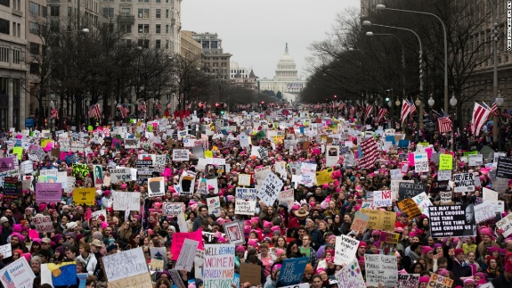

Democracy is NOT a spectator sport! Empowering families to participate in advocacy for our children, our community, the larger society, is its own victory, regardless of the outcome of any particular effort.

Ensure Your Place at the Table! Join or renew your membership in National PLACE today and encourage other family-led organizations to join us at at www.parentsatthetable.org/join-us!
- $125/year for local or state family-led organizations; $275 for national family-led organizations
- Submit comments on important policy issues using National PLACE’s comments supporting the family and family organization voice at ALL decision-making tables!

